**Scrum Meeting Report to Track Progress**

**Note: A different group member should volunteer each scrum report to prepare and turn in this report. That way a particular member does not get overwhelmed doing all reports through the semester.**

**Group Name: Chaotic Coders**

**Reporter:** Ethan

**Date:** 10/2/2024 **Starting Time: 6:30pm Ending Time: 7pm**

**Participants:** Alex, Ethan, Minas, Nura

**Missing Member if any:** N/A

**1. Each member must individually answer the below three questions:**

**a. What have you accomplished during the past two weeks?**

Alex: I have constructed a CRC design for our project over the past two weeks. I set up a database with AWS and am working on connecting it to our application. I have also added the Manager and Account Manager classes and a logic map of how the UI will flow. I began running preliminary tests on the Hotel and User classes to ensure objects can be created successfully.

Ethan: During the past two weeks, I have worked mostly on the reservation aspect of the project. I created a new class called ReservationManager and connected it with the main reservation class which I also modified and fixed a bit to improve receipt printing for the program. For ReservationManager, I ended up modifying a few parts of the Hotel class as well to try and link everything together so that adding a reservation, modifying a reservation, and canceling a reservation would go smoothly.

Minas: Over the past two weeks, I worked on developing the Room class, figuring out the requirements and implementing a working version. I also researched GUI design and created a test version (local) to see what works and what changes or additions are needed to improve it.

Nura: I have created a user class, basic methods, and constructor. I am also learning and working on Jira and GUI.

**b. What are you going to get done during the next two weeks?**

Alex: My Goal for the next two weeks is to get the Account Manager class working and have the ability to create and store User accounts and Manager accounts. My other goal is to update the Rooms class to be abstract and create different room class types. Once that is done I will have the application generate 100 rooms on startup and we can implement the Reservation Manager Controller.

Ethan: During the next two weeks, I am going to further develop my reservation classes to try to get a real functioning program to test out. I need to do more error checking with reservations and also add user inputs (which I may have to delve into the main or hotel class for). I will also be working more on Jira as I have not done it too much recently.

Minas: Complete Room class with its basic requirements, try to get a working GUI and understand what needs to be corrected or improved.

Nura: For the next two weeks, I want to be very familiar with using Jira and GUI. And also update the user class I am working on.

**c. What obstacles do you need to be removed?**

Alex: The current obstacle is my lack of knowledge of AWS databases.

Ethan: My current obstacle is simply lack of experience coding a big project with many classes, but I am overcoming it by working and practicing more.

Minas: Inexperience with GUIs using Java.

Nura: Not very familiar with Jira and GUI

**2. Provide a Burn-down list for current Sprint, i.e., list of user stories that are yet to be completed for** **the current sprint and user stories that have been completed for the current sprint.**

**(embed web link if your user stories are managed via an online platform, give me permission to** **view)**

Below are all the current user stories we have. We have not added many since our last report and our goal is mostly the same for this sprint.

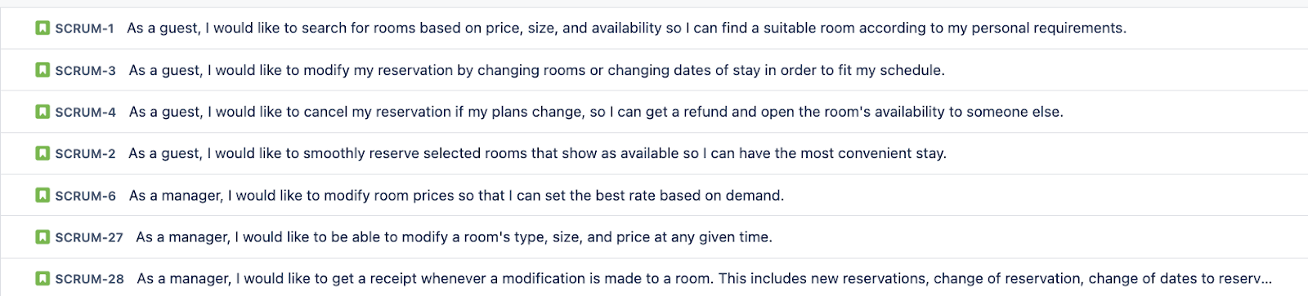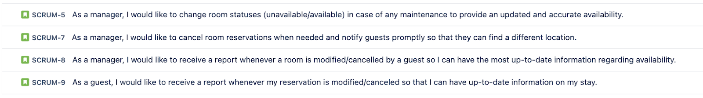

<https://chaotic-coders.atlassian.net/jira/software/projects/SCRUM/boards/1/backlog>

**3. Additionally you are asked to provide a snapshot of Agile Task Board for your project:**

**------------------------------------------------------------------------------------------------------------------------------**

**Agile Task Board - Task board is used to track progress in agile for one particular or a set of user stories.**

**Each user story would require a set of implementation tasks. Your task board should have the below set** **of information:**

**User Story: user story under consideration for current sprint.**

**To Do: Tasks that needs to be picked up.**

**In Progress: Tasks that are currently in progress, with an estimated date of when it would get** **completed.**

**To Verify: Tasks that needs to be verified/tested.**

**Done: Tasks that are completed.**

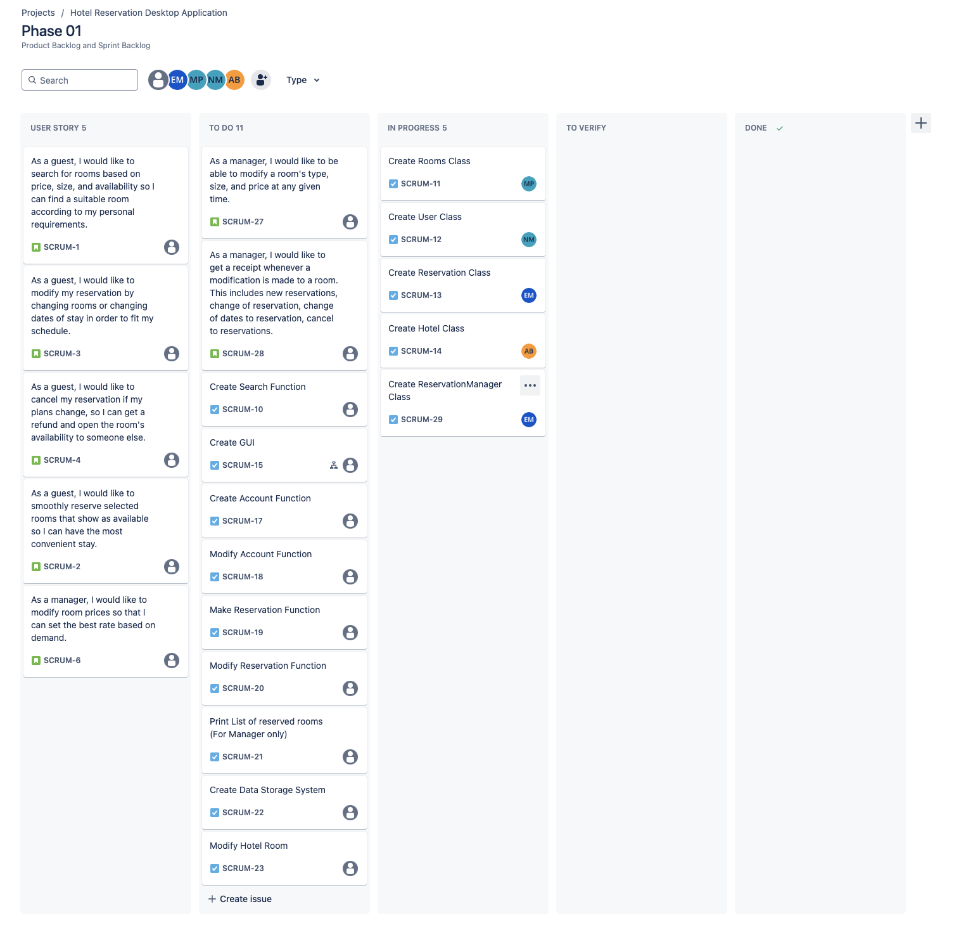

**---------------------------------------------------------------------------------------------------------------------------------**

**Maintain your 2. and 3. Online using a professional project management system. Add me to your agile** **task board and additionally embed the link here and give me permission to view your 2. and 3.**

<https://chaotic-coders.atlassian.net/jira/software/projects/SCRUM/boards/1>

**4. Add me to your GIT repository. Embed link to your repository here.**

<https://github.com/Alexander-Boutselis/Chaotic_Coders.git>

**5. Any other comments:**

No additional comments at this time.